SCOTTISH CAPITAL
INVESTMENT MANUAL

Strategic Assessment
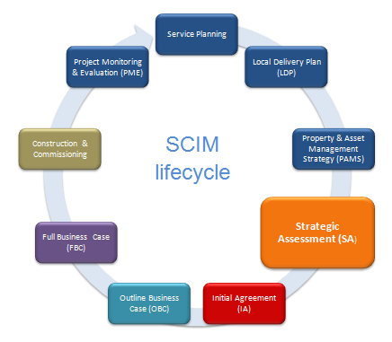

Overview
The main purpose of the Strategic Assessment is to identify and briefly outline the need for change, the benefits it might deliver, and the case for potential investment. It will do this by responding, as appropriate, to the following questions:
Strategic Assessment (SA)
Response
Question
Why is this proposal a good thing to do?
Brief Outline of:
- Current arrangements
- Need for change
- Benefits to be gained
- Fit with Strategic Investment Priorities
What solution is being considered?
Early thoughts on:
- Scope of services covered
- Proposed service arrangement
- Service providers
- Impact on assets
- Value & procurement

The Strategic Assessment can also be used to gain consensus and support from stakeholders and Scottish Government on the scope of change needed and the case for it being an investment priority. The objective is thus to provide clarity, challenge, consensus, and organisational support for the proposal. It is therefore important that the Strategic Assessment is not prepared in isolation or based on a single viewpoint.
A Strategic Assessment is to be completed for all proposals anticipated to need funding approval above the Board’s delegated authority, but it is also considered best practice for consideration of all the Board’s service change and investment proposals. The submission will consist of a single page Strategic Assessment Template which is to be incorporated into the Board’s Property & Asset Management Strategy (PAMS). Blank templates are available on the SCIM website and an example of a completed Template is included in Appendix A.

Why is this proposal a good thing to do?
Response
Question
Why is this proposal a good thing to do?
Brief Outline of:
- Current arrangements
- Need for change
- Benefits to be gained
- Fit with Strategic Investment Priorities
A compelling rationale for investment should demonstrate that the benefits to be gained are significant in relation to the level of investment required, and that they strongly support NHSScotland’s strategic investment priorities. If the rationale for investment is unable to demonstrate these two criteria then the proposal may not be considered further.
Completion of the Strategic Assessment Template is based on responding to the following questions:
- What are the current arrangements?
- What is the need for change?
- What benefits will be gained from addressing these needs?
- How do these benefits link with NHSScotland’s Strategic Investment Priorities?
The expectation is that the information provided will be high level in nature but formed from a wider understanding and appreciation of the case for change and investment need. If the proposal gains support for the development of an Initial Agreement then at that stage a more detailed evidence base will be expected.

What are the current arrangements?
A brief description is required of current arrangements affected by the need for change. This might consider factors such as the type and scope of service provision and/or its location, functional size, service providers, or the properties which support this service, etc.

What is the need for change?
This should identify the greatest needs for change driving forward the investment proposal.
A need for change can relate to an opportunity to provide significant outcomes when compared to existing arrangements, overcoming a problem, or responding to any other driver for change.
Examples of drivers influencing the need for change might include:
- Responding to public opinion / concerns about a service.
- The organisation needing to enhance its service provision or performance.
- The organisation needing to change in order to maintain the quality of service delivery or comply with regulatory requirements.
- Concerns regarding the effectiveness of assets to support modern service delivery.
- Needing to respond to NHSScotland’s policy agenda and its triple aim of improving quality of care, health of the population, and value & sustainability.
At Strategic Assessment stage no more than five drivers for change should be short-listed and described. More detailed evidence of the cause and effect of those needs is not expected until Initial Agreement stage.

What benefits will be gained from addressing these needs?
Up to seven key benefits that will flow if the need for change is addressed should be short-listed and described on the Strategic Assessment. These should be sufficient to demonstrate that the benefits to be gained are significant in relation to the level of investment required. Any dis-benefits may also be noted.

Examples of the types of benefits to be considered include:
- Those which meet public expectations for the service.
- Those which arise from directly addressing the need for change.
- Those which support national outcomes – examples of which can be found in Appendix B.
- Those which might deliver wider public and community benefits.
Lines should also be drawn on the Strategic Assessment Template showing links between each need for change and the responding benefits to be gained from addressing that need.
Details of how these demonstrable benefits will be identified are expected at Initial Agreement stage.

How do these benefits link to NHSScotland’s Strategic Investment Priorities?
The Strategic Assessment Template is also to be used to map links between the proposal’s expected benefits and NHSScotland’s strategic investment priorities. This will help to explain the importance of this proposal and why it should be considered a priority for investment. Further information on the scope and definition of each Strategic Investment Priority is available in Appendix B.
Each strategic investment priority should be scored from a range of 1 - 5 for the proposal’s potential to deliver benefits against this priority. This process needs to align with the following score guide:
Score 5: Substantial | Significant benefits to be delivered against this priority.
Score 4: | In between 5 and 3.
Score 3: Moderate | Reasonable benefits to be delivered against this priority.
Score 2: | In between 3 and 1.
Score 1: Negligible | Small level of benefits to be delivered against this priority.

The ‘Total Score’ on the template is to be gathered from the Capital Planning System (CPS) once the proposal has been created on the system and the individual prioritisation scores entered. This will create a total score which is different from the sum of the individual scores due to inherent weighting of the strategic investment priorities in the CPS.
A prioritised list of Strategic Assessment proposals is to be included in the Board’s Property & Asset Management Strategy. Further information is available in this related guidance.

What solution is being considered?
Response
Question
What solution is being considered?
Early thoughts on:
- Scope of services covered
- Proposed service arrangement
- Service providers
- Impact on assets
- Value & procurement

This should describe early thoughts on the solution being considered to address the need for change and investment; however, as not all proposals will have formed ideas on potential solutions at this stage then a limited response to this question is acceptable in these circumstances.
A brief description is required, based around the following five questions:
- What is the scope and/or size of services being considered?
- What is the proposed service arrangement and/or capacity expectation?
- Who are likely to be the future service providers?
- What impact is likely on assets (new, replacement, refurbishment, etc)?
- What is the likely value of the investment (this should align with any figure already stated on the Board’s Local Delivery Plan) and any thoughts on likely procurement route.

Appendix A
Strategic Assessment Template example
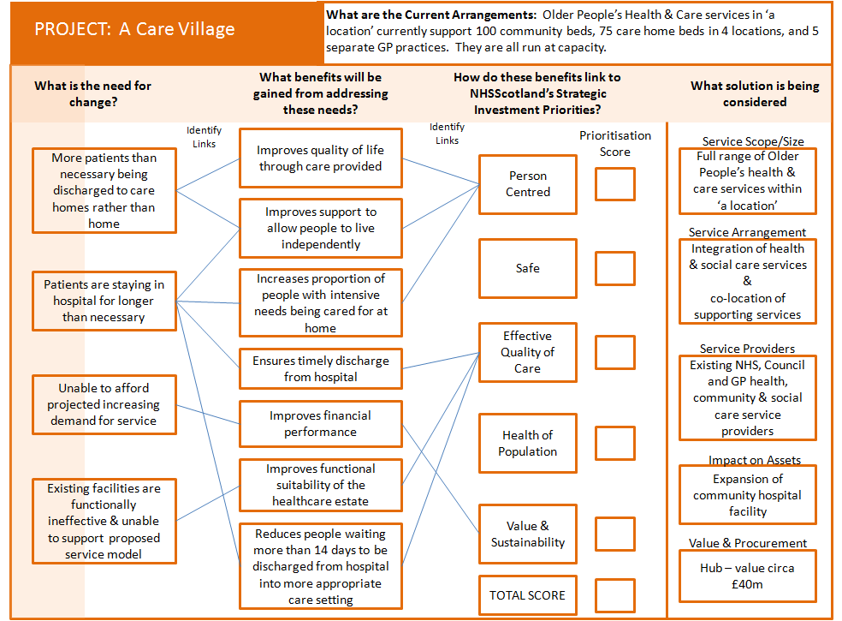

Appendix B
Definitions of NHSScotland’s Strategic Investment Priorities

Person Centered
 | General Definition | Ensures that resources are in place to support people powered health and care services, and promotes personal responsibility and self-management for individuals health and wellbeing
 |  | Indicator | Potential Measure:
1 | QOIs | Supports people in looking after and improving their own health and wellbeing | Percentage of adults able to look after their health very well or quite well
 |  |  | Rate of emergency inpatient bed days for adults
 |  | Ensure that people who use health and social care services have positive experiences and their dignity respected. | Percentage of adults supported at home who agree that their health & care services seemed to be well co-ordinated
 |  |  | Percentage of adults receiving any care or support who rate it as excellent or good
 |  |  | Indicator on people’s experience of their GP practice
 |  |  | Proportion of Care and Care at Home services rated 3 or above in Care Inspectorate Inspections
 |  |  | Proportion of last 6 months of life spent at home or in community settings
 |  | Improves support to allow people to live independently | Percentage of adults supported at home who agree that they are support to live as independently as possible
 |  |  | Rate of emergency inpatient bed days for adults
 |  |  | Percentage of adults with intensive needs receiving care at home
 |  |  | Patient re-admission rate
 |  |  | Delayed discharge rate
 |  | Improves quality of life through care provided | Percentage of adults supported at home who agree that their services and support had an impact in improving or maintaining their quality of life
 |  | Increases proportion of people with intensive needs being cared for at home | TBC
 |  | Increases support for carers | Percentage of carers who feel supported to continue in their caring role
 |  | Improves care home environment | TBC
2 | SAFR | Improves the Physical condition of the health / care estate | Proportion of estate categorised as either A or B for the Physical Condition appraisal facet
 |  | Improves the quality of the healthcare estate | Proportion of estate categorised as either A or B for the Quality appraisal facet
 |  | Improves peoples opinion of the hospital environment | Proportion of positive responses to the In-Patient Questionnaire on patient rating of the hospital environment
 |  | Reduces the age of the Healthcare Estate | Percentage of estate less than 50 years old
 | HEAT / LDP | N/A
3 | Project Specific | All other local and national measurement for quality improvement and performance management. | To be locally developed by the NHS Board

Safe
 | General Definition | Improves safety in the healthcare environment - building on the Scottish Patient Safety Programme in Acute Care, Primary Care, Maternity Services, Paediatrics and Mental Health Care.
 |  | Indicator |  | Potential Measure:
1 | QOIs | Reduces Healthcare Associated Infection |  | Percentage prevalence in acute hospitals
 |  | Reduces adverse harmful events |  | TBC
 |  | Reduces Hospital Standardised Mortality ratio |  | Rate per 100,000 for people aged under 75 in Scotland
 |  | Increases safety of people receiving care and support |  | Percentage of adults supported at home who agree they felt safe
2 | SAFR | Improves statutory compliance |  | Overall percentage compliance score from SCART
 |  | Reduces backlog maintenance |  | Reduction in backlog maintenance costs
 |  | Reduces significant and high risk backlog maintenance |  | Significant & high risk backlog as percentage of total backlog
 | HEAT / LDP | Reduces C.Difficile Infections |  | Number of cases per 1,000 acute occupied bed days
 |  | Reduces MRSA/MSSA Infections |  | Number of cases per 1,000 acute occupied bed days
3 | Project Specific | All other local and national measurement for quality improvement and performance management. |  | To be locally developed by the NHS Board

Effective Quality of Care
 | General Definition | Improves the effective Quality of Care particularly focused on increasing the role of primary care, integrating health and social care, improving the delivery of unscheduled and emergency care, and improving the current approach to supporting and treating people who have multiple and chronic illnesses
 |  | Indicator |  | Potential Measure:
1 | QOIs | Improves end of life care to be as comfortable as possible in a homely environment |  | Percentage of people who spend last 12 months of life at home or in a community setting
 |  | Reduces emergency admissions to hospital |  | Rate of emergency admissions per 100,000 population
 |  | Reduces readmissions |  | TBC
 |  | Ensures timely discharge from hospital |  | TBC
2 | SAFR | Improves the Functional Suitability of the Healthcare Estate |  | Proportion of estate categorised as either A or B for the Functional Suitability appraisal facet
 | HEAT / LDP | Supports newly diagnosed Dementia patients with access to the range of post-diagnostic services |  | Proportion of dementia patients given access to post-diagnostic services
 |  | Reduces the rate of emergency inpatient bed days for people aged 75 |  | Patients aged 75+ per 1,000 population –as a proportion of acute occupied emergency bed days
 |  | Avoids people waiting more than 14 days to be discharged from hospital into a more appropriate care setting, once treatment is complete |  | Number of discharges that took more than 14 days
 |  | Reduces the rate of attendance at A&E |  | Number of unplanned A&E attendances per 100,000 population
 |  | Enables eligible patients commencing IVF treatment within 12 months |  | TBC

 |  | Enables delivery of 18 weeks referral for treatment for Psychological Therapies. | TBC
 |  | Enables delivery of 18 weeks referral for treatment for specialist Child and Adolescent Mental Health Services (CAMHS) services | Percentage of people who start treatment at CAMH services in Scotland within 18 weeks of referral
 |  | Supports 95% of patients waiting less than 4 hours from arrival to admission, discharge or transfer for accident and emergency treatment | Percentage of people waiting less than 4 hours at A&E
3 | Project Specific | All other local and national measurement for quality improvement and performance management. | To be locally developed by the NHS Board

Health of Population
 | General Definition | Improves health of the population particularly focused on the importance of Early Years, reducing Health Inequalities, and preventative measures on alcohol, tobacco, dental health, physical activity and early detection of cancer
 |  | Indicator | Potential Measure:
1 | QOIs | Supports reduction of premature mortality | Death rate among those aged under 75 per 100,000 population
 |  | Supports increase in the number of babies born with a Healthy birth-weight | Percentage of babies born at a healthy birthweight
2 | SAFR | N/a | N/a
 | HEAT / LDP | Supports early cancer detection | Percentage of breast, colorectal and lung cancer cases (combined) diagnosed at stage 1
 |  | Supports smoking cessation initiatives (12 weeks post quit) | Number of successful quits at 12 weeks post quit in the 40% most deprived within Board SIMD areas
 |  | Supports antenatal access | Percentage of pregnant women in each SIMD quintile who will have booked for antenatal care by the 12th week of gestation
 |  | Supports suicide reduction initiatives | Suicide rate per 100,000
 |  | Supports SIMD child fluoride varnishing initiatives | Percentage of 3 & 4 year old children in each Scottish Index of Multiple Deprivation (SIMD) quintile to receive at least two applications of fluoride varnish (FV) per year
 |  | Supports child healthy weight interventions | Number of interventions delivered
3 | Project Specific | All other local and national measurement for quality improvement and performance management. | To be locally developed by the NHS Board

Value & Sustainability
 | General Definition | Supports implementation of the 2020 Workforce Vision through modernisation, leadership and management.  Introduces investment in new innovations to increase quality of care and reduce costs.  Increases efficiency and productivity through unified approaches, local solutions and decision making.
 |  | Indicator | Potential Measure:
1 | QOIs | Increases level of staff engagement | Percentage of staff who they say they would recommend their workplace as a good place to work
 |  | Optimises resource usage | Cost of delayed discharge
 |  |  | Cost of end of life care in acute hospital
 |  |  | Cost of emergency admissions
2 | SAFR | Improves accommodation space utilisation | Proportion of estate categorised as ‘Fully Used’ for the Space Utilisation appraisal facet
 |  | Optimises overall running cost of buildings | Total occupancy cost of building
 |  | Optimises cleaning costs | Cleaning cost £ per sq.m.
 |  | Optimises property maintenance costs | Property maintenance cost £ per sq.m.
 |  | Optimises PPP Facilities management costs | PPP Facilities management cost £ per sq.m.
 |  | Optimises energy usage costs | Energy cost £ per sq.m.
 |  | Optimises rent or rates costs | Rent or rates £ per sq.m.
 |  | Optimises catering costs | Catering cost £ per consumer week or sq.m.
 |  | Optimises portering costs | Portering cost £ per consumer week or sq.m.
 |  | Optimises laundry costs | Laundry cost £ per consumer week or sq.m.
 |  | Optimises waste costs | Waste cost £ per consumer week or sq.m.
 |  | Reduces financial burden of backlog maintenance and/or future lifecycle replacement expenditure | Backlog maintenance cost
 |  |  | Facilities Condition Index (FCI)
 |  | Improves design quality in support of increased quality of care and value for money | AEDET score
 | HEAT / LDP | Improves financial performance | Recurring revenue budgets
 |  | Reduces carbon emissions and/or energy consumption | Percentage reduction in CO2 emissions
 |  |  | Percentage reduction in energy consumption
3 | Project Specific | All other local and national measurement for quality improvement and performance management. | To be locally developed by the NHS Board

